**Electricity Price Prediction Project Design and Innovation**

|  |  |
| --- | --- |
| **Date** | **04-10-2023** |
| **Team ID** | **3879** |
| **Project Name** | **Electricity Price Prediction using Data Science** |

**Table of Contents**

|  |  |
| --- | --- |
| 1 | Introduction |
| 2 | Problem Statement |
| 3 | Design and Innovation Strategies |
| 3.1 | Data Collection and Feature Engineering |
| 3.2 | Data Pre-processing |
| 3.3 | Model Selection and Training |
| 3.4 | Geographic Analysis |
| 3.5 | Market Sentiment Analysis |
| 3.6 | Explainable AI (XAI) |
| 3.7 | Continuous Learning |
| 4 | Conclusion |

**1. Introduction**

This document outlines the comprehensive design and innovation strategies for the development of a Data Science-based Electricity Price Prediction model. Accurate electricity price prediction is pivotal in the energy sector, facilitating informed decision-making for consumers and providers. This project is committed to leveraging innovative approaches to enhance prediction precision and contribute to a more efficient energy market.

**2. Problem Statement**

The objective is to build a predictive model that leverages historical electricity price data along with pertinent influencing factors to make accurate forecasts of future electricity prices. This model serves as a valuable tool for both energy providers and consumers, enabling them to make informed decisions regarding their electricity consumption and investment strategies. By analysing past trends and considering key variables, such as demand, supply, and market dynamics, this model aims to provide valuable insights into the potential cost of electricity, facilitating better planning and decision-making in the energy sector.

**3. Design and Innovation Strategies**

**3.1. Data Collection and Feature Engineering**

Innovation: Holistic Data Gathering

Employ advanced data collection methods, including real-time data feeds, historical pricing data, and regulatory updates, to create a comprehensive dataset.Apply innovative feature engineering techniques, including time-based aggregations, lag features, and domain-specific feature creation, to extract valuable insights from the data.Generate novel features such as renewable energy contribution, demand elasticity indicators, and market sentiment scores to enhance prediction accuracy.

**3.2. Data Pre-processing**

Innovation: Anomaly Detection and Data Normalization

Utilize advanced statistical methods and machine learning algorithms for anomaly detection to identify and handle outliers effectively .Normalize data to account for varying scales and units, ensuring consistency across features and enhancing model performance .Implement time series decomposition to capture seasonality and trends within the electricity price data.

**3.3. Model Selection and Training**

Innovation: Time Series Forecasting and Ensemble Learning

Employ state-of-the-art time series forecasting models, including ARIMA, SARIMA, and Prophet, to capture temporal patterns and price fluctuations .Leverage ensemble learning techniques such as Random Forests, Gradient Boosting, and XG Boost to combine diverse models and enhance prediction accuracy.Incorporate deep learning architectures, such as Recurrent Neural Networks (RNNs) and Long Short-Term Memory (LSTM) networks, to capture intricate nonlinear relationships within the data

**3.4. Weather and Demand Integration**

Innovation: Weather-Based Predictions and Demand Modeling. Integrate weather data into the model to account for its impact on electricity demand and supply.

Develop demand forecasting models considering factors such as population growth, industrial activity, and economic indicators. Utilize advanced regression techniques to model the complex relationships between weather variables, demand, and electricity prices.

**3.5. Regulatory Analysis**

Innovation: Regulatory Impact

Assessment Analyse the influence of regulatory changes, including pricing mechanisms and renewable energy policies, on electricity prices.. Develop predictive models incorporating regulatory factors to anticipate price fluctuations resulting from policy shifts. Employ natural language processing (NLP) techniques to extract insights from regulatory documents and government communications.

**3.6. Explainable AI (XAI)**

Innovation: Model Transparency and Interpretability

Implement Explainable AI (XAI) techniques, including SHAP (SHapley Additive exPlanations) values and feature importance analysis, to provide transparent explanations for price predictions. Create an interactive dashboard that visualizes model outputs, enabling stakeholders to understand the factors driving electricity price forecasts.Enhance transparency and user trust by offering clear insights into the model's decision-making process.

**3.7. Continuous Learning**

Innovation: Adaptive Model Enhancement

Establish a continuous learning framework that integrates real-time data feeds and user feedback to update and enhance the model's performance.Regularly retrain the model to adapt to evolving energy market dynamics, ensuring long-term accuracy and relevance.Implement automated data pipelines for seamless data ingestion, preprocessing, and model retraining.

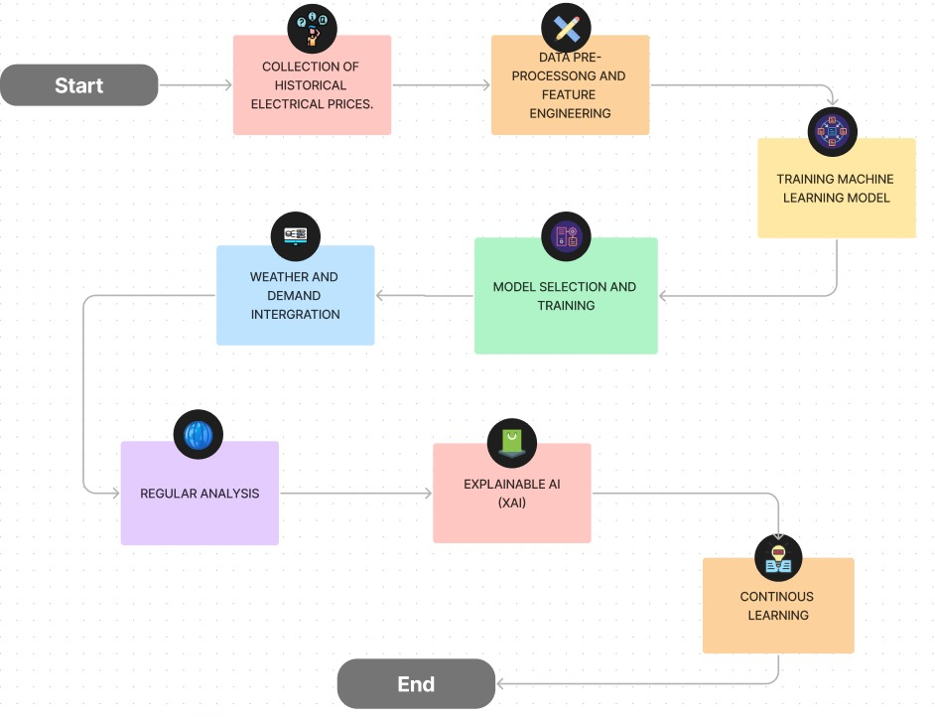

**4. Conclusion**

In conclusion, the Electricity Price Prediction project embodies a holistic approach to address the complexities of predicting electricity prices accurately. By integrating innovative strategies such as comprehensive data collection, advanced feature engineering, ensemble learning, weather and demand integration, regulatory analysis, Explainable AI (XAI), and continuous learning, this project aspires to develop a robust model. This model will serve as a valuable tool for energy market stakeholders and contribute to the advancement of data science in the energy industry. By combining cutting-edge technologies and techniques, we aim to offer a comprehensive and insightful solution for electricity price prediction.